Voice-based Email System

Software Requirement Specification
Version 1.0

Prepared By
Megha K C
Priyanga P Kini
Srividya Krishnakumar
Karthik Suresh
Document Control Data Sheet

Project Code | CMS
Project Name | Courier Management System
Document Name | Software Requirement Specification
Version | 1.0
File Name | CourierManagementSystem_SRS.doc
Classification | Confidential
Client

 | Name | Signature & Date
Prepared By

Reviewed By

Approved By

Distribution List

Revision History

Version | Date | Author | Reviewer | Change Description

Table of Contents
1. Introduction 5
1.1 Purpose 5
1.2 Intended Audience 5
1.3 Product Scope 5
1.4 Definitions, acronyms and abbreviations 5
1.5 References 6
2. Overall Description 7
2.1 Product Perspective 7
2.2 Product Functions 7
2.3 User Classes 7
2.4 Development Environment 8
2.5 Constraints 8
2.6 Assumptions and Dependencies 9
3. External Interface Requirements 10
3.1 User Interfaces 10
3.2 Hardware Interfaces 10
3.3 Software Interfaces 10
3.4 Communications Interfaces 10
4. System Features 10
4.1 Use cases 11
4.1.1 Use Case – 1: Login 12
4.1.2 Use Case – 2: Logout 13
4.1.3 Use Case – 3: Search service availability 14
4.1.4 Use Case – 4: Book consignment 16
4.1.5 Use Case – 5: Amount calculation 18
4.1.6 Use Case – 6: Payment 20
4.1.7 Use Case – 7: Track status 21
4.1.8 Use Case – 8: View booking details 23
4.1.9 Use Case – 9: Register complaint 25
4.1.10 Use Case – 10: View complaint reply 26
4.1.11 Use Case – 11: View user details 28
4.1.12 Use Case – 12: Update user details 30
4.1.13 Use Case – 13: Signup 31
4.1.14 Use Case – 14: View branch details 33
4.1.15 Use Case – 15: View employee details 35
4.1.16 Use Case – 16: Edit branch details 37
4.1.17 Use Case – 17: Edit employee details 39
4.1.18 Use Case – 18: Pickup 41
4.1.19 Use Case – 19: Delivery 43
4.1.20 Use Case – 20: Non delivery details 45
4.1.21 Use Case – 21: View complaint 46
4.1.22 Use Case – 22: Complaint reply 47
4.1.23 Use Case – 23: Generate report 49
4.1.24 Use Case – 24: Print barcode 51
5. Other Nonfunctional Requirements 54
5.1 Performance Requirements 54
5.3 Security Requirements 54

Introduction

Purpose
The purpose of the Software Requirements Specification document is to maintain all the functions and the specifications of ‘Courier Management System’. Besides it contains detailed descriptions of all the requirements specified.

Intended Audience
This intended audience of this document includes all stakeholders of CMS project who are supposed to review and sign-off this document. The primary stakeholders of the system include registered users, guest users, administrator, pickup staff, delivery staff etc.

Product Scope
The project named ‘Courier Management System’ aims at implementing a software system that would manage the essential activities of any courier company and to maintain their details systematically. The traditional manual methods of calculation of rate of consignment, creating periodical reports, billing etc are made easier, faster and accurate in the proposed system. The system shall allow the user to login from anywhere, track their consignment, complaint about their consignment if any etc. The system also shall enable administrator to generate periodical reports, modify details, and manage complaints. Various functions like pickup, delivery, consignment rate calculation etc. are also included in the system. The ultimate aim is to ensure the smooth and efficient functioning of the courier company by managing its resources and utilities effectively.

Definitions, acronyms and abbreviations

Abbreviations
CMS - Courier Management System
SRS - Software Requirement Specification

Definitions
Consignment: The parcel that has to be shipped or delivered.

Pickup staff: The user responsible for collecting the consignment from the sender and to ship the consignment.

Delivery staff: The user responsible for delivery of consignment.

References
IEEE Recommended Practice for Software Requirements Specifications-IEEE Std 830-1998.

Overall Description

Product Perspective
Courier Management System is independent and totally self. The CMS application is customizable and can be used by any courier company with minimal configuration changes.

Product Functions
The project aims at developing interactive software based system that would almost completely automate the essential processes of courier management system. The various functionalities to be dealt by system are classified into different modules.

The proposed software shall have the following modules or functions:

  - Booking Module
  - Login Module
  - Complaint management Module
  - Report Module
  - Pickup Module
  - Delivery Module
  - Maintenance Module
  - Consignment tracking module

User Classes
The users of this system will include the users, staff and administrator. The user classes for the system being developed have been broadly classified as follows. The actors of the 23 use cases mentioned in section 4 can be classified under the 5 user classes listed below.

- Registered user
- Guest
- Admin
- Pickup staff
- Delivery staff

User | Characteristics
Registered user | - Login  - Book consignment  - Track consignment  - Complaint about consignment  - Search availability of service  - Update his personal details  - View his/her personal details  - View booking details
Guest | - Book consignment  - Track consignment  - Complaint about consignment  - Search availability of service  - View booking details
Administrator | - Login  - Generate periodical reports  - View branch and employee details  - Edit branch details  - Edit employee details  - View complaints and reply
Pickup staff | - Login  - View booking details  - Update pickup status
Delivery Staff | - Login  - View booking status  - Update delivery status

Development Environment
Development environment is as follows. Final decision on the development environment shall be taken during the design phase.

- ASP.NET
- Database: Oracle 10g
- Web Server: Apache HTTP Server
- Business objects Reporting Services
- Internet Explorer 7.0

Constraints
- Regulatory Policies: NA
- Hardware Limitations: NA
- Interfaces to other application: An external interface for online bill payment is provided.
- Parallel operations: NA
- Audit Functions: NA
- Control Functions: NA
- Safety and Security Considerations: The password and a valid username are the security issues. The backup process at the server side shall satisfy data protection.
- Reliability Requirements: Total number of bugs in the system shall not exceed 1% of the total line number of code, except connection reliability, which is out of range.
- Criticality of the Application: The server applications shall be available 365 days.

Assumptions and Dependencies
The following assumptions are made with regard to this project:

- The user must have credit/debit cards or net banking facility for online booking

- It is assumed that the duration of the project is about 5 months, this is only a rough estimate.

- All the hardware and software requirements of the team to carry out the development activities are not finalised.

External Interface Requirements

User Interfaces
CMS is a web based online data entry and display system. All users interact with the system using user friendly Graphical User Interfaces (GUI). The formats of various GUIs like screens, web pages and reports of the system shall be furnished in the design document.

Hardware Interfaces
No hardware interface is required for the system.

Software Interfaces
Courier management system should integrate online payment interface to enable online transactions using net banking/debit card/credit card.

Communications Interfaces
Users will access the application using web browsers like Internet Explorer 7.0. The communication will be through standard HTTP protocol and SMTP protocol.

System Features
This section gives the details of system features and functions identified as different use cases relevant for various users (or actors) of the system. The following sections group and specify the use cases according to the 5 user classes identified and listed under section 2.3.

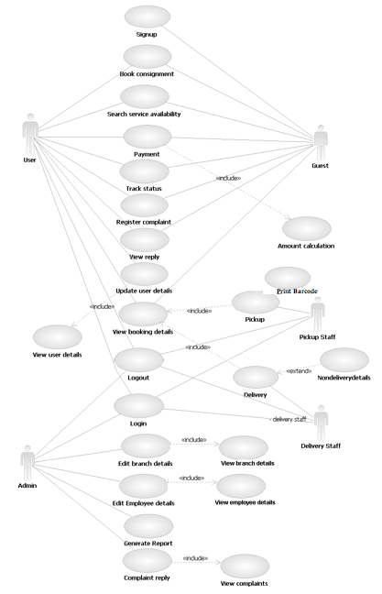
Use cases

4.1.1 Use Case – 1: Login
Description:

The user can login to the system.

Actors:

The actors include registered user, admin and staff.

Precondition:

The User should be registered to the system.

Main Flow of Events:

- The system prompts to enter username and password.

- User enters username and password.

- System validates username and password.

- If the details are valid, user logs in to the system.

Alternate Flow of Events:

3.a. If the details are not valid, system displays invalid user message.

Post condition:

The system displays users home page.

Relationships:

NA

Activity Diagram:

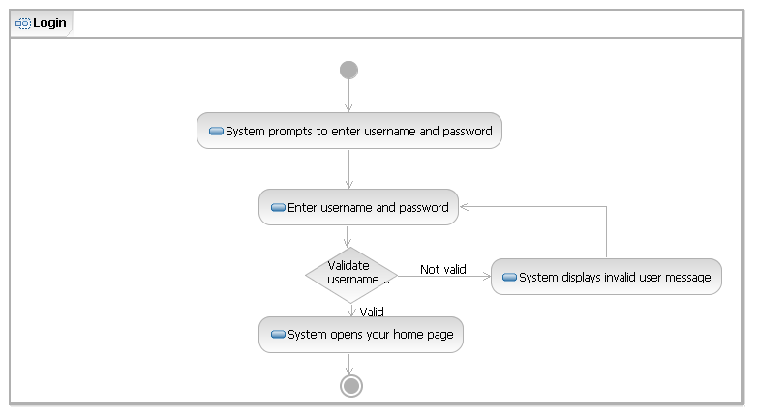

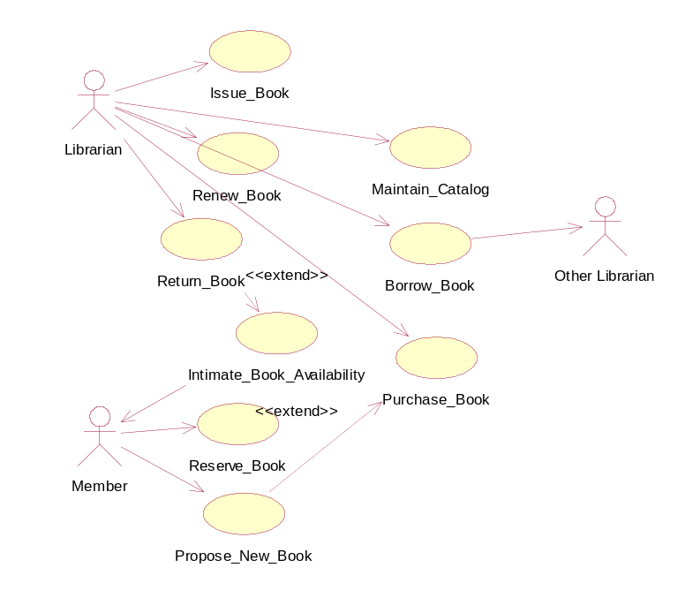
Special Requirements:

NA

4.1.2 Use Case – 2: Logout
Description:

The User can logout from system.

Actor:

The actors include registered user, admin and staff.

Precondition:

The User should be logged in to the system.

Main Flow of Events:

- The user selects logout option.

- System logout from users profile.

Alternate Flow of Events:
NA

Post condition:
NA

Relationships:
NA

Activity Diagram:
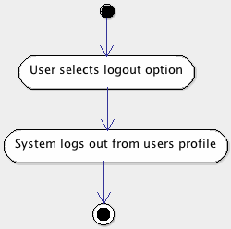
Special Requirements:

NA

4.1.3 Use Case – 3: Search service availability
Description:

The User can search service availability at a given destination.

Actors:

The actors include registered user, guest.

Precondition:

The User should be logged in to the system.

Main Flow of Events:

- The user selects search availability option.

- System prompts to enter destination and pincode.

- System checks if service is available at the given destination.

- If yes, system displays service available.

Alternate Flow of Events:

3a. If no, System displays service not available.

Post condition:

NA

Relationships:

NA

Activity Diagram:

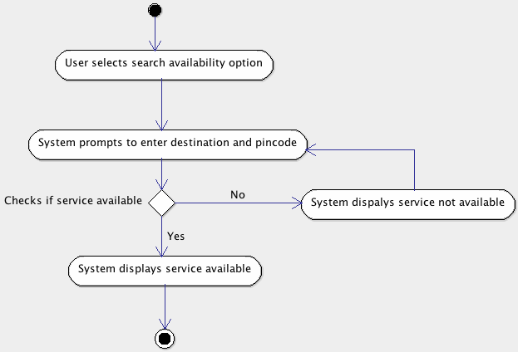

Special Requirements:

NA

4.1.4 Use Case – 4: Book consignment
Description:

The User can book consignment.

Actor:

The actors include registered user, guest.

Precondition:

The User should log in to the system.

Main Flow of Events:

- The user selects book consignment option.

- System prompts to enter destination address.

- System checks if service is available at the given destination.

- If yes, system prompts to enter consignment details.

- System saves the consignment details.

Alternate Flow of Events:

3a. If no, System displays service not available.
3b. Goto 2.

Post condition:

System calculates amount from weight of the consignment entered

Relationships:

NA

Activity Diagram:

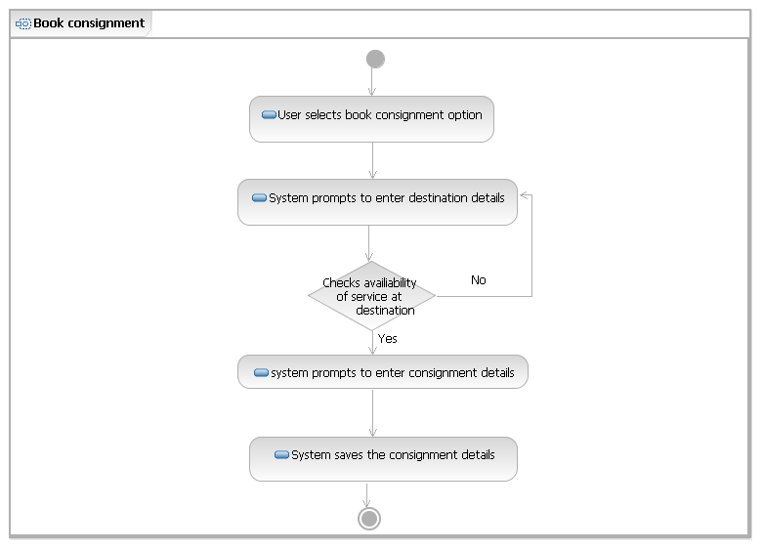
Special Requirements:

NA

4.1.5 Use Case – 5: Amount calculation
Description:

System calculates total price of consignment.

Precondition:

The User should add the consignment details.

Main Flow of Events:

- System gets weight of consignment.

- System multiplies the weight with standard rate per gram.

- System displays the amount.

Alternate Flow of Events:

NA

Post condition:

System displays pay option

Relationships:

NA

Activity Diagram:

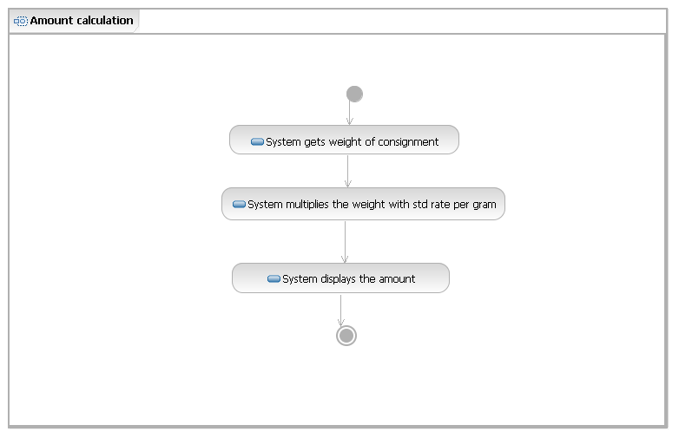
Special Requirements:

NA

4.1.6 Use Case – 6: Payment
Description:

User can make the payment.

Actors:

The actors include Registered user, guest.

Precondition:

The User should add the consignment details.

Main Flow of Events:

- User selects pay option.

- System redirects to payment interface.

- Checks if payment is success.

- If payment is success, redirects to confirmation page.

- System generates consignment number and barcode.

- Exit.

Alternate Flow of Events:

3.a. If payment not success, redirects to failure page.
3.b. 6

Post condition:

User receives consignment number and barcode.

Relationships:

Includes: Amount calculation

Activity Diagram:

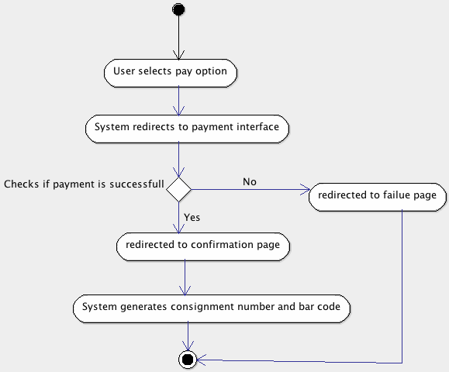

Special Requirements:

NA

4.1.7 Use Case – 7: Track status
Description:

User can track the status of consignment.

Actors:

Actors include Registered user, guest.

Precondition:

The User should book a consignment.

Main Flow of Events:

- User selects track status option.

- System prompts to enter consignment number.

- System checks if consignment number is correct.

- If yes, system displays consignment details.

- Exit.

Alternate Flow of Events:

3.a. If no, system displays invalid consignment number.
3.b. goto 2

Post condition:

NA

Relationships:

NA

Activity Diagram:

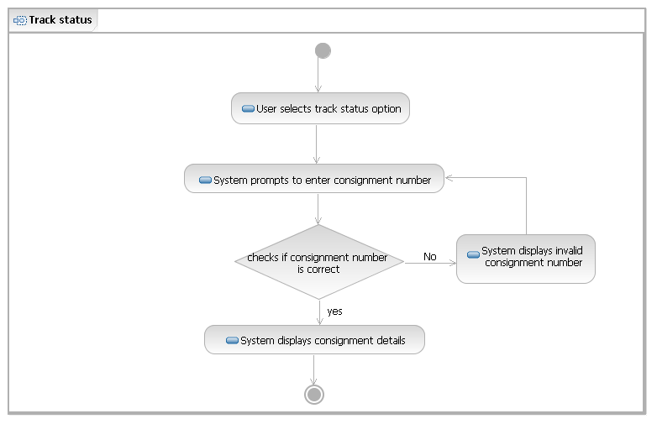

Special Requirements:

NA

4.1.8 Use Case – 8: View booking details
Description:

User can view the booking details.

Actors:

Actors include Registered user, guest, pickup staff, delivery staff.

Precondition:

The User should book a consignment.

Main Flow of Events:

- User selects view booking details option.

- System checks if there is any booking detail.

- If yes, system displays booking details.

- Exit.

Alternate Flow of Events:

3.a. If no, system displays no booking details.
3.b. goto 1

Post condition:

NA

Relationships:

NA

Activity Diagram:

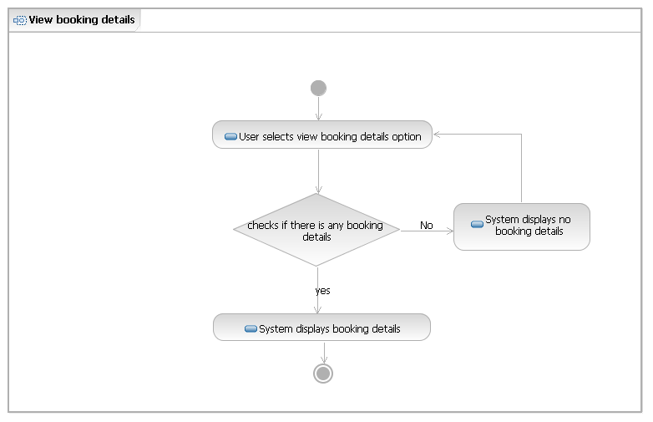

Special Requirements:

NA

4.1.9 Use Case – 9: Register complaint
Description:

User can register complaint about late delivery, damaged goods etc.

Actors:

The actors include Registered user, guest.

Precondition:

The User should be the direct participant of a consignment order.

Main Flow of Events:

- User selects register complaint option.

- System prompts to enter consignment number.

- User enters consignment number.

- System checks if consignment number is valid.

- If valid, system prompts to enter complaint.

- User enters complaint.

- System saves complaint and generates complaint id.

- Exit

Alternate Flow of Events:

5.a. If not valid, system displays invalid consignment number.

Post condition:

Complaint successfully registered.

Relationships:

NA

Activity Diagram:

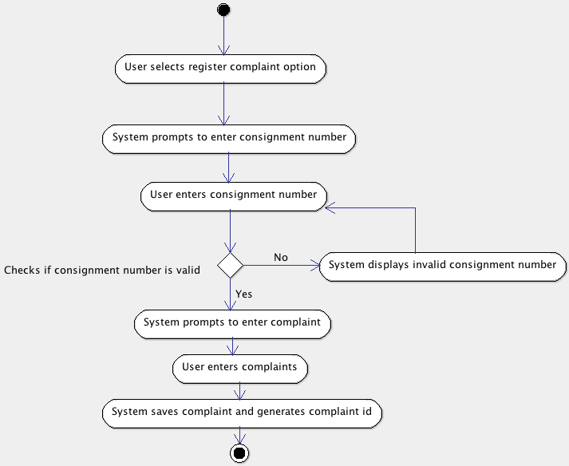

Special Requirements:

NA

4.1.10 Use Case – 10: View complaint reply
Description:

User can view complaint reply by administrator.

Actors:

The actors include registered user, guest.

Precondition:

The User should register complaint.

Main Flow of Events:

- User selects view complaint reply option.

- System prompts to enter complaint id.

- System checks if there is any reply.

- If yes, system displays complaint reply.

- Exit.

Alternate Flow of Events:

3.a. If no, system displays not received any replies.

Post condition:

NA

Relationships:

NA

Activity Diagram:

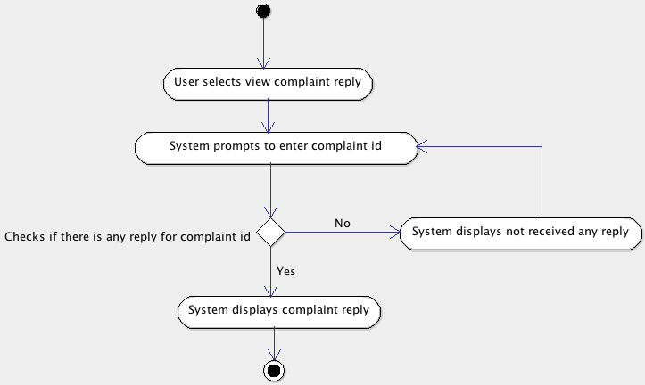

Special Requirements:

NA

4.1.11 Use Case – 11: View user details
Description:

User can view user details.

Actors:

Actors include registered user.

Precondition:

The User should log in to the system.

Main Flow of Events:

- User selects view user details option.

- System displays user details.

- Exit.

Alternate Flow of Events:

NA

Post condition:

User has viewed his/her details.

Relationships:

NA

Activity Diagram:

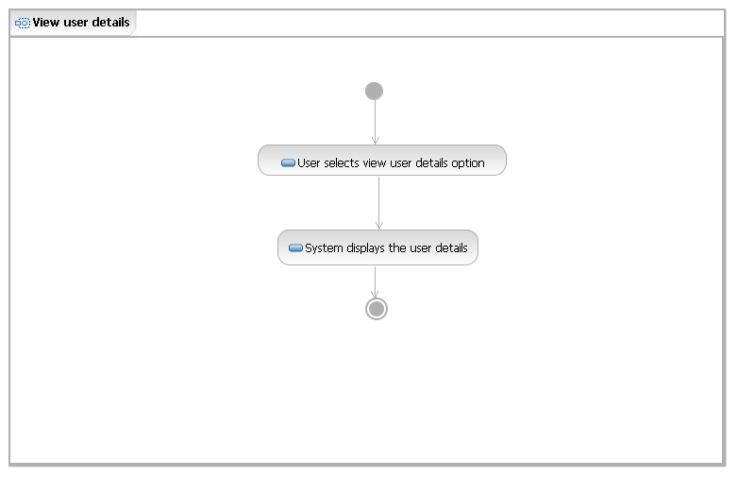

Special Requirements:

NA

4.1.12 Use Case – 12: Update user details
Description:

User can update user details.

Actors:

Actors include update user details.

Precondition:

The User should log in to the system.

Main Flow of Events:

- User selects update user details option.

- System navigates to user details page.

- User updates the details

- System saves the details

- Exit.

Alternate Flow of Events:

NA

Post condition:

System updates user details successfully.

Relationships:

Include: View user details

Activity Diagram:

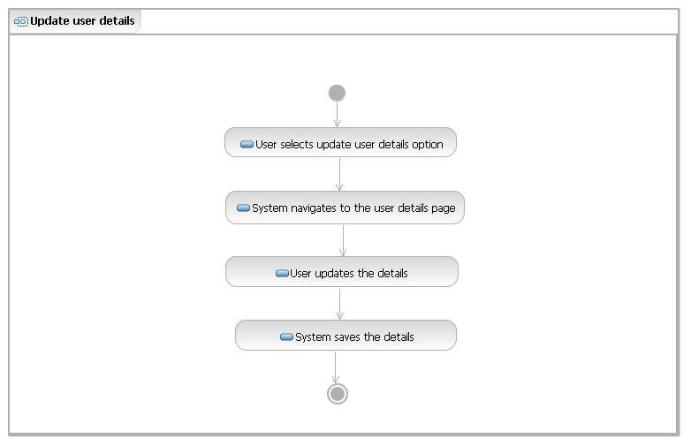
Special Requirements:

NA

4.1.13 Use Case – 13: Signup
Description:

User can signup or register.

Actors:

Actors include guest.

Precondition:

The User should have a valid mail id.

Main Flow of Events:

- User selects signup option.

- System prompts to enter details-mail id, username, password, name etc.

- User enters the details.

- System validates mail id.

- If mail id is valid, system saves user details successfully.

Alternate Flow of Events:

4.a. If mail id is not valid, goto 2

Post condition:

User can log in to the system with username and password.

Relationships:

NA

Activity Diagram:

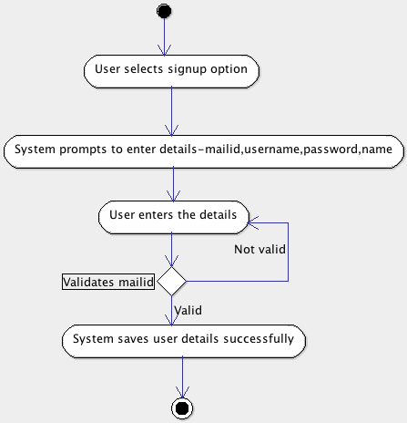

Special Requirements:

NA

4.1.14 Use Case – 14: View branch details
Description:

Administrator can view the branch details.

Actors:

Actor is administrator.

Precondition:

The Administrator should login to the system.

Main Flow of Events:

- Admin selects view branch details option.

- System prompts to enter branch code.

- Admin enters branch code.

- System checks if branch code is valid.

- If yes, system displays branch details.

- Exit

Alternate Flow of Events:

4.a. If no, system displays invalid branch code.

Post condition:

Administrator has viewed branch details.

Relationships:

NA

Activity Diagram:

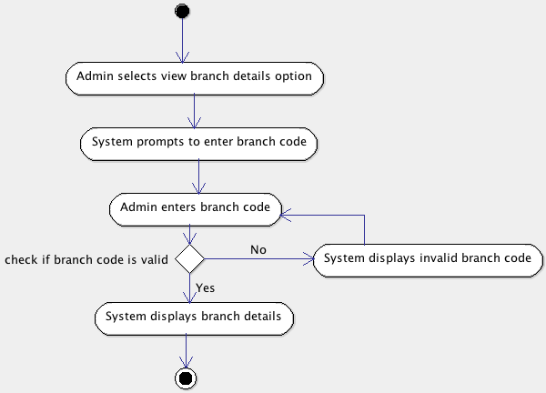

Special Requirements:

NA

4.1.15 Use Case – 15: View employee details
Description:

Administrator can view the employee details.

Actors:

Actor is administrator.

Precondition:

The Administrator should login to the system.

Main Flow of Events:

- Admin selects view employee details option.

- System prompts to enter employee id.

- Admin enters employee id.

- System checks if employee id is valid.

- If yes, system displays employee details.

- Exit

Alternate Flow of Events:

NA

Post condition:

Administrator has viewed employee details.

Relationships:

NA

Activity Diagram:

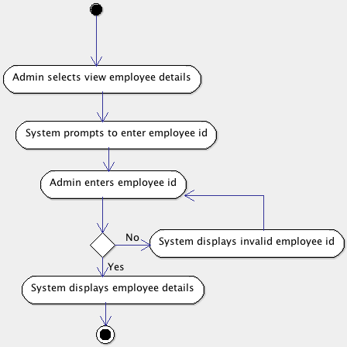

Special Requirements:

NA

4.1.16 Use Case – 16: Edit branch details
Description:

Administrator can edit the branch details.

Actors:

Actor is administrator.

Precondition:

The Administrator should login to the system.

Main Flow of Events:

- Admin selects edit branch details option.

- System displays add, update and delete options.

- Admin selects add, update or delete options.

- Admin add branch details, update or delete branch details.

- Exit

Alternate Flow of Events:

NA

Post condition:

Administrator successfully edits branch details.

Relationships:

Include: View branch details

Activity Diagram:

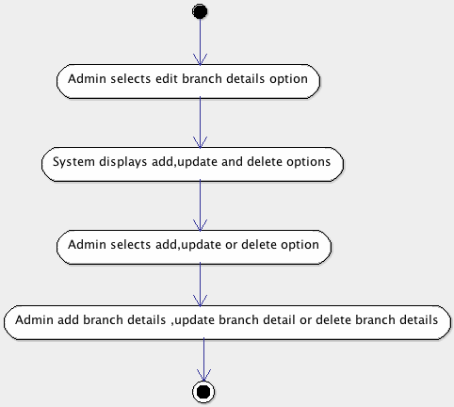

Special Requirements:

NA

4.1.17 Use Case – 17: Edit employee details
Description:

Administrator can edit the employee details.

Actors:

Actor is administrator.

Precondition:

The Administrator should login to the system.

Main Flow of Events:

- Admin selects edit employee details option.

- System displays add, update and delete options.

- Admin selects add, update or delete options.

- Admin add branch details, update or delete employee details.

- Exit

Alternate Flow of Events:

NA

Post condition:

Administrator successfully edits employee details.

Relationships:

Include: View employee details

Activity Diagram:

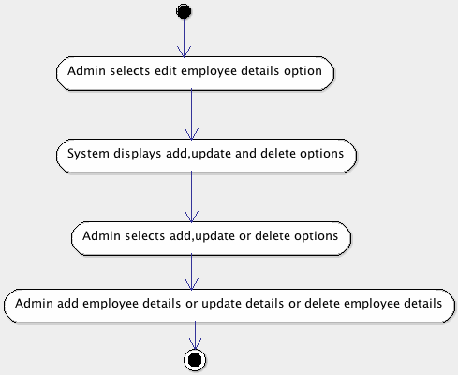

Special Requirements:

NA

4.1.18 Use Case – 18: Pickup
Description:

Pickup staff can update shipping details of consignment.

Actors:

Actor is pickup staff.

Precondition:

Pickup staff should login to the system.

Main Flow of Events:

- staff selects booking detail of consignment.
- Staff updates the status of consignment to assigned or shipped.
- System checks if the status is shipped
- If status is shipped, system sends mail to user that consignment is shipped.
- Exit

Alternate Flow of Events:

3.a if status is not shipped, goto 5.

Post condition:

Staff successfully updates status of consignment.

Relationships:

Includes: View booking details.

Activity Diagram:

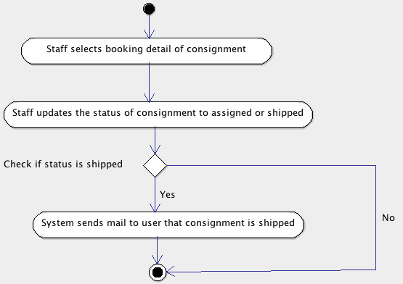

Special Requirements:

NA

4.1.19 Use Case – 19: Delivery
Description:

Delivery staff can update delivery details of consignment.

Actors:

Actor is delivery staff.

Precondition:

Delivery staff should login to the system.

Main Flow of Events:

- Staff selects booking detail of consignment.
- Staff updates the status of consignment to assigned, delivered or not delivered.
- System checks if the status of consignment is delivered or not delivered.
- If the status is delivered or not delivered, System sends mail to user that consignment is delivered or not delivered.
- Exit

Alternate Flow of Events:

3a. If no, goto 5

Post condition:

Staff successfully updates status of consignment.

Relationships:

Includes: View booking details.
Extends: Non delivery details.

Activity Diagram:

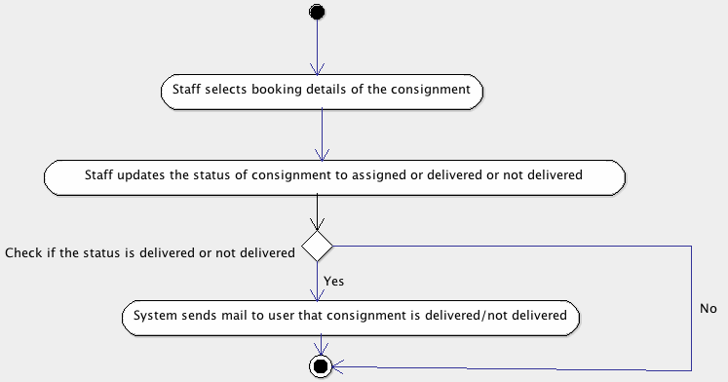

Special Requirements:

NA

4.1.20 Use Case – 20: Non delivery details
Description:

Delivery staff can update details of not delivery of consignment.

Actors:

Actor is delivery staff.

Precondition:

Delivery staff should update status of consignment.

Main Flow of Events:

- System checks the status of consignment.
- If not delivered, system prompts to enter reason.
- Staff updates the details of not delivery
- Exit

Alternate Flow of Events:

1.a goto 4

Post condition:

Staff successfully updates details of not delivery.

Relationships:

NA

Activity Diagram:

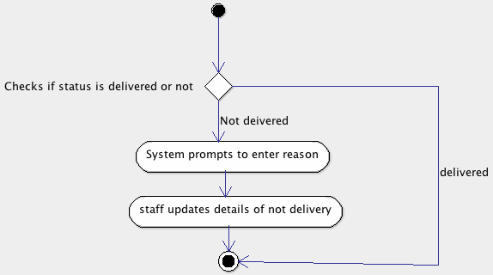

Special Requirements:
NA

4.1.21 Use Case – 21: View complaint
Description:

Admin can view complaints.

Actors:

Actor is admin.

Precondition:

User should register complaint.

Main Flow of Events:

- User selects view complaint option.
- System displays complaint details.
- Exit

Alternate Flow of Events:

NA

Post condition:

Admin has successfully viewed complaints.

Relationships:

NA

Activity Diagram:
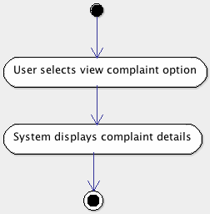

Special Requirements:

NA

4.1.22 Use Case – 22: Complaint reply
Description:

Admin can reply to complaints.

Actors:

Actor is admin.

Precondition:

User should register complaint.

Main Flow of Events:

- Admin selects reply to complaint option.
- System prompts to enter reply to complaint.
- Admin enters reply.
- System saves reply.
- Exit

Alternate Flow of Events:
NA

Post condition:

System successfully saves complaint reply.

Relationships:

Includes: View complaint.

Activity Diagram:

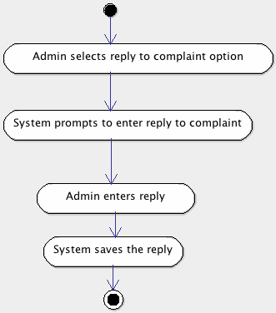

Special Requirements:

NA

4.1.23 Use Case – 23: Generate report

Description:

Admin can generate report for a specific period.

Actors:

Actor is admin.

Precondition:

Admin should log in to system.

Main Flow of Events:

- User selects generate report option.
- System prompts to select period.
- Admin selects period.
- Admin clicks on generate option.
- System displays report.
- Exit

Alternate Flow of Events:

NA

Post condition:

Admin has successfully viewed report.

Relationships:

NA

Activity Diagram:
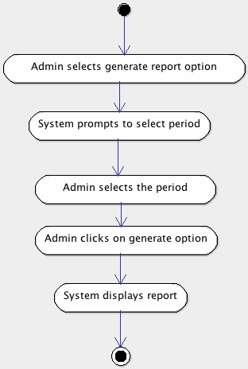

Special Requirements:

NA

4.1.24 Use Case – 24: Print barcode

Description:

Pickup staff can print the barcode of a consignment.

Actors:

Actor is pickup staff.

Precondition:

Staff should log in to system.

Main Flow of Events:

- Staff selects booking details of the consignment.
- Staff selects the print barcode option.
- System prints the barcode.
- Exit

Alternate Flow of Events:

NA

Post condition:

Pickup staff has taken print out of barcode.

Relationships:

NA

Activity Diagram:

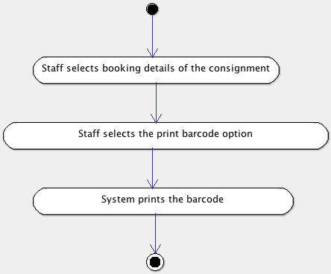

Special Requirements:

NA

Other Nonfunctional Requirements

5.1 Performance Requirements
Major performance requirements are:

- All webpages should be loaded within 10 seconds
- The system should handle 1000 users at a time

5.3 Security Requirements
The access to the software application will be restricted to the authorized users identified by a valid username and password. Guest users can register or signup to the system with a valid mail id. The users will be categorized into various roles like registered user, guest user, administrator, pickup staff, and delivery staff. The modules and functions accessible or available to the users will vary based on their roles. The users will be able to login to the application using the username and password and access the modules or functions based on their role.

